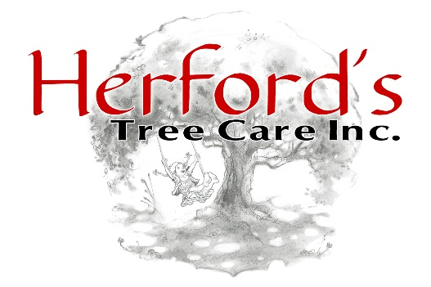
PROPERTY ACCESS CONSENT FORM
PLEASE COMPLETE THIS FORM WITH EACH NEIGHBORING PROPERTY
WHOSE PROPERTY MAY BE AFFECTED BY THE PROPOSED TREE WORK.
ONE SIGNED FORM IS REQUIRED PER NEIGHBORING PROPERTY.

If the scheduled tree work requires access across any portion of a neighboring property, this form must be completed and submitted with the approved proposal prior to the start of the work.
My Address: ___________________________________________________________________________
Neighbor’s Name: ______________________________Neighbor’s Phone: ______________________
Neighbor’s Address: ____________________________________________________________________
Neighbor’s Email: ______________________________________________________________________

Description of Work
To my neighbor: I am having the following work performed at my property (please describe the work being completed):
_______________________________________________________________________________________
_______________________________________________________________________________________
The nature of this work may require Herford’s Tree Care, Inc. to temporarily access a portion of your property in order to safely perform the work. By signing below, you acknowledge and grant permission for such access. Herford’s Tree Care, Inc. will exercise reasonable care to help protect driveways, sidewalks, landscaping, lawn areas, irrigation systems, and other surrounding property during the course of the work. However, due to the nature of tree work and the use of heavy equipment, incidental disturbance or damage may occasionally occur. Except in cases of negligence or willful misconduct, Herford’s Tree Care, Inc. shall not be held responsible for incidental damage associated with providing the requested access.

Project Homeowner’s Signature __________________________________ Date: ___________________
Neighbor’s Signature ____________________________________________ Date: ___________________

